

**BALDIVIS SECONDARY COLLEGE**

**APPLICATIONS - Unit 3 & 4**

**2020 Test 3 – Networks**

Student Name ______________________ Teacher Name ______________________

**Time allowed for this task:** 55 minutes, in-class, test conditions.

Section 1: 28 minutes + 2 minutes reading time

Section 2: 26 minutes + 2 minutes reading time

**Materials required:** **Section 1 Resource free section (28 marks)**

Standard writing equipment

SCSA Formula Sheet

Section 2 Calculator assumed section (27 marks)

Calculator (to be supplied by the student)

SCSA formula Sheet

One page A4 (single sided) hand written notes

**Marks available:** **55 marks**

**Task Weighting: 7%**

**Section 1: Resource Free [28 marks]**

**Question 1** **[3,2,2,1,2 – 10 marks**]

Consider the network below:

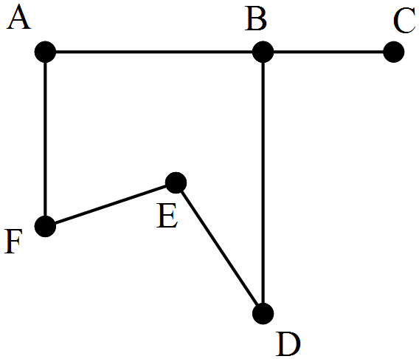



(a) State the number of faces, vertices and edges.

(b) State the degree of each vertex.

(c) Is the graph simple? Justify your answer.

(d) Name an edge that is a bridge for the network.

(e) Is the graph Eulerian, Semi-Eulerian or neither? Justify your answer.

**Question 2 [3,2,2,2 - 9 marks]**

The table below shows the distances, in kilometres, along direct footpaths between the checkpoints A, B, C, D, E, F and G at a national park.

1. Complete the graph below to show this information.

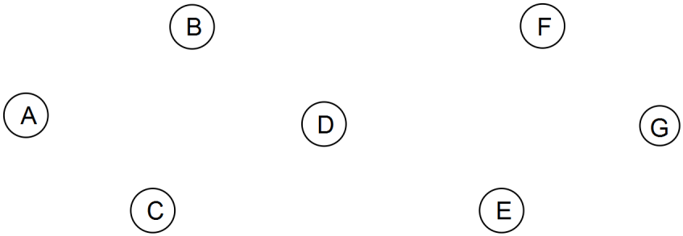

A park worker is at Checkpoint D and needs to visit all the other checkpoints just once and then return to D.

(b) The worker leaves Checkpoint D, walks to Checkpoint A and then visits the rest of the checkpoints just once before returning to D. List the other checkpoints visited, in order, and state the total length of this route.

(c) Is the trail in (b) a Hamiltonian path or cycle? Explain your answer.

(d)   A shorter cycle, starting and finishing at D, is possible for the worker. List the order the checkpoints should be visited to achieve the smallest total length and state this length.

**Question 3 [3,3,3 - 9 marks]**

Over the years, a regional authority has found that the presence of a supermarket, a bank, a service station and a hotel was a good indicator of a country town’s well-being.

Below is shown a section of the table containing this information for some of the country towns.

|  |  |  |  |  |  |
| --- | --- | --- | --- | --- | --- |
|  |  | Service provided | | | |
|  | Bank  (B) | Supermarket (M) | Service Station  (S) | Hotel  (H) |
|  | Katanning | Yes | Yes | Yes | Yes |
| Towns | Collie | No | Yes | Yes | No |
|  | Moora | No | No | Yes | Yes |

(a) Display the information in the table as a bipartite graph.

(b) Looking at this bipartite graph of the three towns, an officer at the regional authority commented that the graph was planar.

(i) When is a graph planar?

(ii) Draw the bipartite graph again, showing that it is planar.

(c) The officer also commented that if Moora had one more of the service providers, the bipartite graph would no longer be planar.

(i) To which of the service providers was the officer referring?

(ii) Draw the bipartite graph again showing why with this additional piece of information displayed on the graph, it is no longer a planar graph?

**End of Section 1**



**BALDIVIS SECONDARY COLLEGE**

**APPLICATIONS - Unit 3 & 4**

**2020 Test 3 – Networks**

Student Name ______________________ Teacher Name ______________________

**Time allowed for this task:** 55 minutes, in-class, test conditions.

Section 1: 28 minutes + 2 minutes reading time

Section 2: 26 minutes + 2 minutes reading time

**Materials required:** Section 1 Resource free section (28 marks)

Standard writing equipment

SCSA Formula Sheet

**Section 2 Calculator assumed section (27 marks)**

Calculator (to be supplied by the student)

SCSA formula Sheet

One page A4 (single sided) hand written notes

**Marks available:** **55 marks**

**Task Weighting: 7%**

**Question 4** **[2,3– 5 marks]**

A simple graph is shown below.

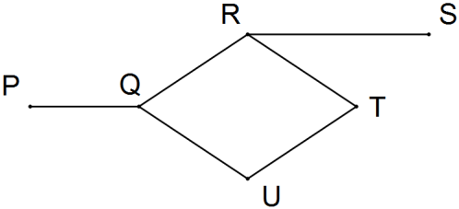

(a) Explain why the graph is simple.

(b) Clearly explain why the graph contains a Hamiltonian path but not a Hamiltonian cycle.

**Question 5** **[3,3– 6 marks]**

The network below shows the distances in km of each road connecting seven towns.

Having just passed her driving test Yusuke decides to cruise around this network.

(a) Find the shortest path from A to B and state the distance.

(b) Vanessa is at town N wants to travel to town M and back to N. All roads through B are blocked and no road may be travelled more than once. Find the length of the shortest path showing all your working?

**Question 6** **[3,2,2,1– 8 marks]**

Adele, Bob, Chen and Daisy all have work in the same office and have their own email addresses. Adele and Bob both know each other's email addresses and Adele and Chen both know Daisy's email address. Bob also knows Chen's email address and Daisy knows Bob's email address.

(a) Construct a digraph to show the above information, ignoring the fact that everyone knows their own email address.

(b) Construct an adjacency matrix, *A*, for the digraph in (a) so that the entry *ARC* is the number of directed edges from vertex *R* to vertex *C*.

(c) Calculate the matrix *B*, where *B*  = *A*2 + *A* .

(d) Use matrix *B* to identify which of the workers, if any, are unable to email the other three workers either directly or by asking one other worker to forward their email.

Question 7 [2,2,1,3 - 8 marks]

The graph below represents 14 canals that meet at locations $A$ to $H$.

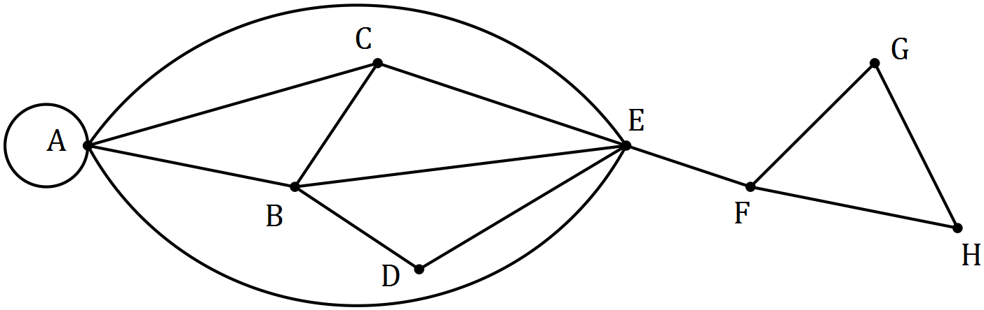

(a) A canal enthusiast noticed that the graph contained a semi-Eulerian trail. State the two properties of a walk that make a semi-Eulerian trail.

(b) Verify that this graph is planar using Euler’s rule

(c) Suggest a suitable starting point for the canal enthusiast to begin a semi-Eulerian trail and indicate where they will finish the trail.

(d) Draw a subgraph of the above graph that is simple, connected, has no bridges and has 8 edges.

**End of Test**